**CHAPTER I**

**INTRODUCTION**

**SOIL MOISTURE DETECTION SYSTEM (IOT)**

Water is a very precious resource and must be properly utilized. Agriculture is one of those areas which consume a lot of water. Irrigation is a time consuming process and must be done on a timely basis.

The aim of the article is to develop a soil moisture detection system which measures the moisture of the soil and automatically turns on or off the water supply system. The project requires very less human involvement once installed. The circuit is based on PIC microcontroller and also a soil moisture sensor.

A properly configured soil moisture sensor can save up to 60 percent of water used in irrigation. In relatively warm temperatures and low relative humidity, plants feel easy to transpire. This reduces the need for fertilizing the plant. Also, high humidity in the air promotes the growth of mold and bacteria on the surface of the plants. This results in plant death and crop failure. Fungus and pests which feed on the plant roots also start accelerating in growth due to high humidity levels. The temperature required by plants to grow optimally also varies from plant to plant but obviously too high or too low temperatures kill plants.

**1.1 SYSTEM OVERVIEW**

**1.1.1 PROPOSED MODEL WITH ARCHITECTURE**

Soil Moisture Detection Method is the method used to build this project. Soil moisture project is intended for the development of an irrigation system that switches submersible pumps on or off by using relays to perform this action on sensing the moisture content of the soil.

The main advantage of using this irrigation system is to reduce human interference and ensure proper irrigation.

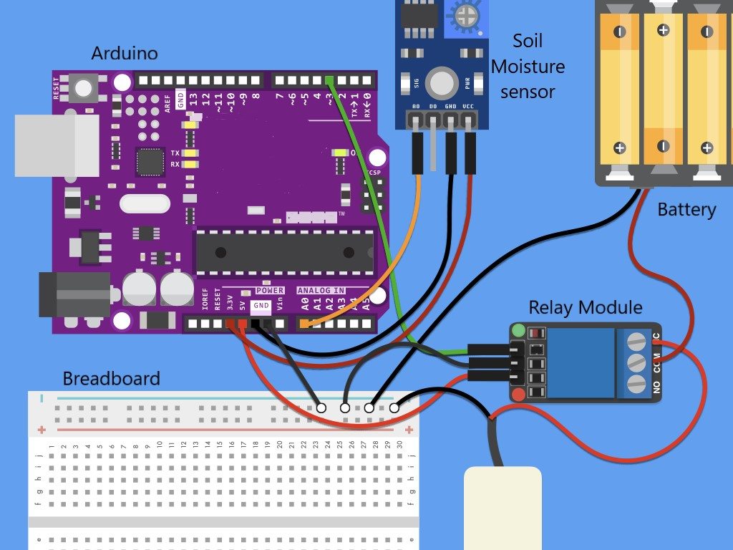

**Fig 1.1.1 Architecture Diagram**

Arduino controls the pump based on the soil moisture level read and shows you the soil moisture level. When the soil moisture drops below the threshold value, water is pumped through the tubing for 1 second. In fact, platforms like Arduino work well with python, especially for applications that require integration with sensors and other physical devices.

**1.2 AIM AND OBJECTIVE:**

Irrigation is defined as artificial application of water to land or soil. Irrigation process can be used for the cultivation of agricultural crops during the span of inadequate rainfall and for maintaining landscapes. An automatic irrigation system does the operation of a system without requiring manual involvement of persons. Every irrigation system such as drip, sprinkler and surface gets automated with the help of electrical appliances and detectors such as computer, timers, sensors and other mechanical devices.

Project Objective - The Sensor Interface can be broken own into three main components: The LCD, the microcontroller, and the sensors which it communicates with. The LCD and microcontroller are essentially the support behind the sensors to collect, store, transfer and display data. Designing more advanced sensors was beyond the scope of this project, so the LCD and microcontroller became the areas of focus. The Sensor Interface was designed to accept a wide variety of sensors, analog, digital, wired and IC. Any of the sensors can also be connected to another Bluetooth module to allow a wide variety of wireless sensors to communicate with the central Sensor Interface microcontroller. Monitor the moisture content of the soil using a soil moisture sensor and the water level of the tank using a float switch. Turn the motor ON when the soil moisture falls below a certain reference value and if there is enough water in the tank. Display the founded report.

**CHAPTER II**

**LITERATURE SURVEY**

**2.1** **SOIL MOISTURE MEASUREMENT**

Moisture content of the soil is a major factor determining plant growth, especially in irrigated systems. Currently there are many and varied methods for determining soil water content on a volume basis or a tension as described by Gardener. The basic objective of irrigation scheduling is to minimise water stress of the plant, that of over irrigation, and under irrigation. The manager aims to manipulate the biological process of cell elongation and cell reproduction for improved plant yield and maximum use of available effluent.

This allows the development of a soil moisture profile estimation algorithm in later chapters, which will be applicable to the soil moisture measurements available. The review of soil moisture profile estimation techniques is provided.

**2.2 POINT MEASUREMENT OF SOIL MOISTURE PROFILES**

It has long been recognised that reliable, robust and automated methods for the measurement of soil moisture content can be extremely useful, if not essential, in hydrologic, environmental and agricultural applications. Over the last 70 years, this recognition has fostered the investment of a considerable amount of ingenuity in developing such methods.

### **2.3 SOIL MOISTURE AND REMOTE SENSING**

The soil moisture content differs vertically and horizontally and, therefore, varies with soil volume. This is highly relevant for the choice of the measurement method, as some approaches might only provide estimates of the top few centimeters, as is the case with remote-sensing technology Thus, near-surface soil moisture and volumetric soil moisture content, i.e., the ratio between the volume of water and volume of soil (unit m3/m3), is most commonly used in remote sensing. Soil type, landscape characteristics, and atmospheric variables are the main controls of the spatial and temporal variability of soil moisture Parameters that affect soil moisture change in response to precipitation input are, for example, soil texture (especially particle size), which determine the water-holding capacity of the soil. Other landscape characteristics that affect the response are soil depth, underlying bedrock, slope, and altitude relative to the surrounding landscape. Passive and active microwave sensors have been identified as the most consistent providers of temporal and spatial retrieval of soil moisture data, although certain limitations occur. Passive sensors are affected by cloud cover, which is a frequently occurring situation during flood events. Cloud removal methods must thus be applied to obtain any useful data. However, passive sensors have been used in several flood studies, due to other advantages like abundant spectral features of multi-spectral imagery with long temporal availability, which is suitable for evaluating long-term effects of flooding. Active sensors have the ability to penetrate clouds and thus derive information during precipitation events, but the long revisit time restricts the use of rapid responses. However, several active sensors with higher temporal and spatial resolution have been launched (e.g., COSMO-SkyMed, TerraSAR-X, and Envisat ASAR), thus enhancing the conditions for effective flood monitoring. The retrieval of soil moisture data depends on large differences between the dielectric constant of water and dry soil, as the soil moisture content influences the soil electrical permittivity.

**CHAPTER III**

**SYSTEM ANALYSIS**

**3.1 EXISTING SYSTEM METHODS**

An automatic irrigation system does the work quite efficiently and with a positive impact on the place where it is installed. Once it is installed in the agricultural field, the water distribution to crops and nurseries becomes easy and doesn’t require any human support to perform the operations permanently. Sometimes automatic irrigation can also be performed by using mechanical appliances such as clay pots or bottle irrigation system. It’s very hard to implement irrigation systems because they are very expensive and complex in their design. By taking some basic points into considerations from experts’ support, we have implemented some projects on automatic irrigation system by using different technologies. Soil moisture monitoring is divided into two broad categories – direct and indirect monitoring. Direct methods measure soil volumetric water content. These methods are destructive, tedious, time-consuming, and non-continuous. In contrast, indirect soil moisture monitoring methods measure volumetric water content using related properties based on a calibration equation. Various factors such as soil physical and chemical properties, soil temperature, and the accuracy of the factory calibration equation can affect the performance of indirect sensors. Depending on the sensor’s technology (such as sensor response time, sensing volume, operational range, etc.), different soil moisture monitoring devices respond differently in different soil environments.

# **Three ways to Automatic Plan Irrigation System using Microcontroller:**

1. Automatic Irrigation System on Sensing Soil Moisture Content
2. Solar Powered Auto Irrigation System
3. GSM Based Automatic Irrigation System

## **3.1.1 AUTOMATIC IRRIGATION SYSTEM ON SENSING SOIL MOISTURE CONTENT**

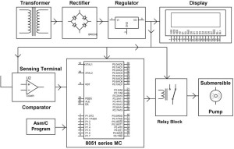

**Fig 3.1.1 Block diagram of automatic irrigation system on sensing soil moisture**

The automatic irrigation system on sensing soil moisture project is intended for the development of an irrigation system that switches submersible pumps on or off by using relays to perform this action on sensing the moisture content of the soil. The main advantage of using this irrigation system is to reduce human interference and ensure proper irrigation. Once the microcontroller gets the data from the sensing material it compares the data as programmed in a way, which generates output signals and activates the relays for operating the submersible pump. The sensing arrangement is done with the help of two stiff metallic rods that are inserted into the agricultural field at some distance. The required connections from these metallic rods are interfaced to the control unit for controlling the operations of the pump according to the soil moisture content.

## **3.1.2 SOLAR POWERED AUTO IRRIGATION SYSTEM**

## 

## Solar Powered Auto Irrigation System Blockdiagram

**Fig 3.1.2 Block diagram of solar powered auto irrigation system**

In the above figure 3.1.2, the power from utilities is required to operate the system. As an extension to the above discussed system, this system uses solar panels to power the circuit. In agricultural field, the proper usage of automatic irrigation method is very vital due to some shortcomings of the real world like scarcity of land reservoir water and scarcity of rainfall. The water level (the ground water table) is getting reduced due to continuous extraction of water from the ground and thus gradually resulting in water scarcity in the agricultural zones slowly turning them into barren lands.

## **GSM BASED AUTOMATIC IRRIGATION SYSTEM**

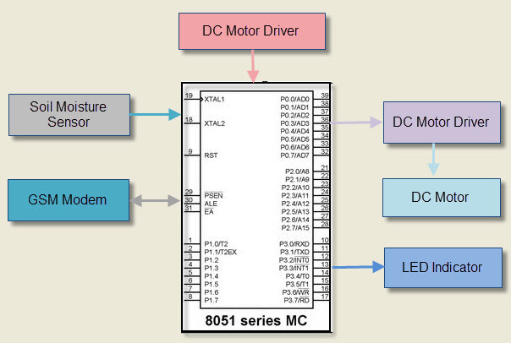

**Fig 3.1.3 Block diagram of GSM Based Automatic Irrigation System**

Nowadays farmers are struggling hard in the agricultural fields round the clock. They do their field work in the morning section and irrigate their land during night time with intermittent intervals. The task of irrigating fields is becoming quite difficult for the farmers due to lack of regularity in their work and negligence on their part because sometimes they switch on the motor and then forget to switch off, which may lead to wastage of water. Similarly, they even forget to switch on the irrigation system, which again leads to damage to the crops. To overcome this problem, we have implemented a new technique by using GSM technology.

**3.2 REQUIREMENT SPECIFICATION**

**3.2.1 SOFTWARE REQUIREMENTS**

A software requirement specification is a description of a software system to be developed. It lays out functional and non-functional requirements and may include a set of use cases that describe user interaction that the software must provide.

1. Language : C, C++
2. Software App : Arduino IDE
3. Operating System : Windows 10-64 bit and above

**3.2.2 HARDWARE REQUIREMENTS**

These pre-requisites are known as (computer) System requirements and are often used as a guideline as opposed to an absolute rule. Most software defines two set of system requirements: Minimum and recommended.

1. Hardware component: Arduino Uno Microcontroller.
2. 9V snap connector kit – Battery, Male-to-Male Jumper wires, Male-to-Female Jumper wires, Breadboard.
3. Plant watering kit - Relay Module, Soil Moisture sensor, Water pump & tubing.

**3.3 LANGUAGE SPECIFICATION**

In this work, the soil moisture detection system based on a low power microcontroller was technologically advanced and deployed. To overcome the disadvantages of the existing system like a high price, problematic in maintenance and wired assembling, we introduce a new system that will have a wireless connection between server and nodes. We introduce a new design of embedded web servers making use of the Arduino controller.

**3.3.1 STEPS TO CREATE SOIL MOISTURE DETECTION SYSTEM**

Step 1 - Hardware Assembly.

Step 2 - Install the code.

Step 3 - Test Your Soil Moisture Sensor & Calibrate.

Step 4 - Water your plant.

# **Step 1 - Hardware Assembly**

1. Connect the VCC on the relay to 5V pin on Arduino
2. Connect GND from the relay to the negative power rail of the breadboard
3. Connect IN on relay to Pin 8 on Arduino
4. Connect negative (black) wire from the battery pack to the negative power rail of the breadboard
5. Connect the black wire of the pump to the negative power rail of the breadboard
6. Connect the AOut from the soil moisture sensor to A0 on the Arduino
7. Connect the GND from the soil moisture sensor to GND on the Arduino
8. Connect the VCC from the soil moisture sensor to 3.3v on the Arduino
9. Connect the red wire from the pump to the NC on the relay
10. Connect the black wire from the pump to the GND rail of your breadboard
11. Connect the red wire from the battery pack to COM on the relay
12. Connect negative power rail from the breadboard to GND on the Arduino
13. Connect the Arduino to pc via USB
14. Connect the water tubing to the pump
15. Place the pump in a container of water

# **Step 2 - Install the code**

1. Next Install Arduino ide with the command sudo apt-get install Arduino
2. Click File, Examples, Basic, Blink to open the Blink.ino
3. Select your Board and your Port from Tools (Arduino Uno) and the port that your Arduino is plugged into
4. Upload Blink.ino to check your Arduino is connected and working properly. If it works, the light on your Arduino should blink intermittently.

# **Step 3 - Test Your Soil Moisture Sensor & Calibrate**

1. Start a new project on Arduino IDE
2. type the code to your Arduino IDE
3. Verify and Upload to your Arduino
4. Click Tools, then Serial Monitor
5. Dip the soil moisture sensor in and out of the container of water to watch the values change. Note the value when dipped in water.
6. Insert the soil moisture sensor into your plant's soil
7. Note the value of your soil. It is best to start with dry soil

# **Step 4 - Water your plant**

1. Arrange the tubing so that the water flows back into the water container
2. Start a new project on Arduino IDE
3. Copy the code to your Arduino IDE
4. Verify and Upload to your Arduino
5. Click Tools, then Serial Monitor
6. Dip the soil moisture sensor in and out of the container of water to watch the pump turn on and off. Pump should turn on when sensor is out of water and off when sensor is in water.
7. With the sensor in the water, position the tubing to plant watering.
8. Insert the sensor into the soil and watch your plant get watered.
9. Assuming your plant is "fully watered," take note of that value as max soil moisture.
10. Adjust the 'threshold' value to a value of your choice between dry soil value and max soil moisture value.
11. Save and upload your adjusted code to your Arduino
12. Continue to monitor your soil moisture level and iterate on your threshold value until you find the right soil moisture level for your plant.

**3.4 BENEFITS**

The benefits of optimizing irrigation scheduling with soil moisture sensors includes increasing crop yields, saving water, protecting local water resources from runoff, saving on energy costs, saving on fertilizer costs and increasing the farmer profitability.

* Irrigation and watering play a substantial role in determining the quality and yields of farming. More appropriate is the process of watering of the fields, more favourable are the end results.
* Time saving.
* No need Extra work Hard.
* Save Water, accordingly our Requirement of water, depends upon water level quantity soil and crops.
* Money Saving (Electricity bile + Water).

**CHAPTER IV**

**SYSTEM DESIGN**

**4.1 SYSTEM ARCHITECTURE**

Design of a system consists of classes, interfaces and collaboration. UML provides class diagram, object diagram to support this. Implementation defines the components assembled together to make a complete physical system. UML component diagram is used to support implementation perspective. The way in which the structure of the project takes place. It depicts the flow as well as the format in which its done.

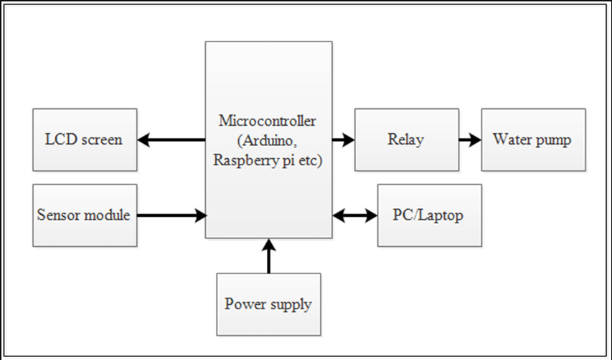

**Fig 4.1 System Architecture**

**4.2 USE CASE DIAGRAM**

The diagram is used to model the system/subsystem of an application. A single use case diagram captures a particular functionality of a system. These internal and external agents are known as actors. So use case diagram are consists of actors, use cases and their relationships.

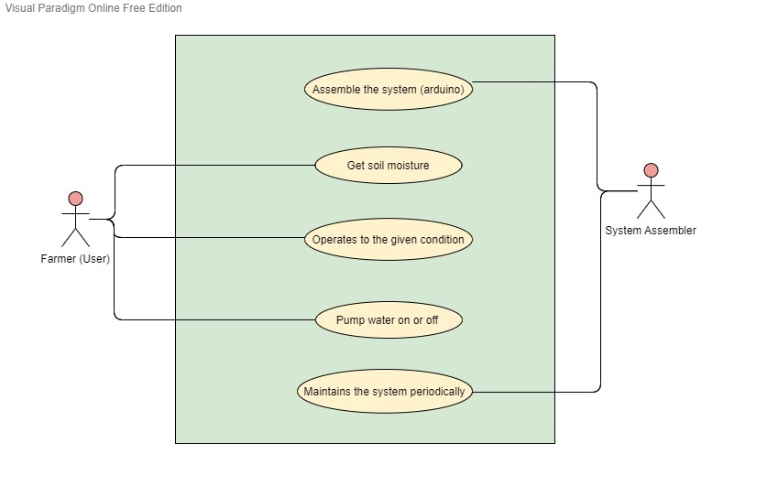

**Fig 4.2 Use case diagram**

So, use case diagram are consists of actors, use cases and their relationships. The use case diagram depicts the project flow sequence. It starts from the login page which is considered to be the home page. It travels through all the modules respectively as per users’ choice.

**4.3** **ACTIVITY DIAGRAM**

Activity diagram is another important diagram in UML to describe dynamic aspects of the system. Activity diagram is basically a flow chart to represent the flow from one activity to another activity. The activity can be described as an operation of the system. So, the control flow is drawn from one operation to another. Activity diagram contains a start button and proceed with the flowchart tools. It contains decision making loops such as the remanufacturing option, chat application, exotic design page, etc. It ends with a finish button.

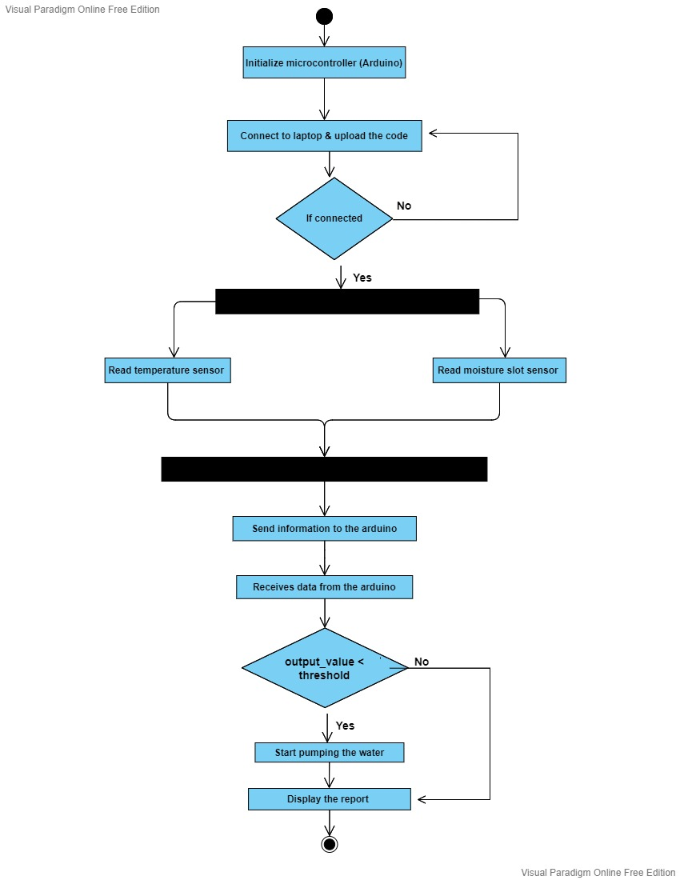

**Fig 4.3 Activity diagram**

**4.4 SEQUENCE DIAGRAM**

Sequence diagram is the most common kind of interaction diagram, which focuses on the message interchange between a number of lifelines. Sequence diagram describes an interaction by focusing on the sequence of messages that are exchanged, along with their corresponding occurrence specifications on the lifelines.

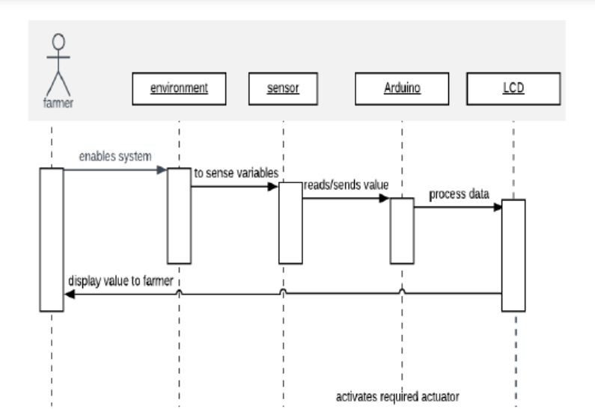

**Fig 4.4 Sequence diagram**

**4.5 COMPONENT DIAGRAM**

Component diagram is a special kind of diagram in UML. The purpose is also different from all other diagrams discussed so far. It does not describe the functionality of the system but it describes the components used to make those functionalities. Component diagrams are different in terms of nature and behaviour. Component diagrams are used to model physical aspects of a system.

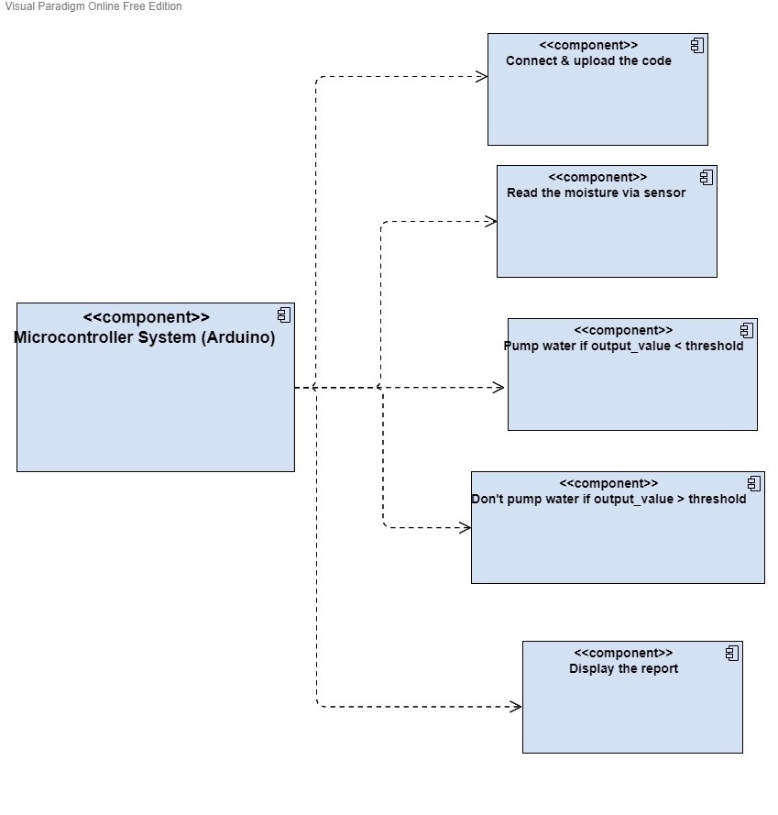

**Fig 4.5 Component diagram**

**CHAPTER V**

**SYSTEM IMPLEMENTATION**

**5.1 MODULE DESCRIPTION**

**5.1.1 ARDUINO UNO**

# 

**Fig 5.1.1 Arduino UNO**

The Arduino Uno is a microcontroller board founded on the ATmega328P (Arduino UNO) microcontroller. The ATmega328 on the board comes pre-programmed with a boot loader that allows uploading new code to it without the use of an exterior hardware programmer

# **5.1.2 SOIL MOISTURE SENSOR**

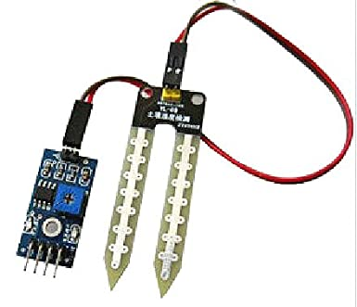

**Fig 5.1.2 Soil moisture sensor**

Soil moisture sensor measures the water level in the soil. It uses the property of the electrical opposition of the soil. The connection between the measured things and soil moisture is regulated and it may vary depending on environmental factors such as temperature, soil type, or electric conductivity. Here, it is used to sense the moisture in the field and transmission it to the microcontroller in order to take controlling action of switching water pump ON/OFF. By using the data from the sensor network, watering is automated. It saves 53% of water than a sprinkler system and more than 80% of water when compared to the traditional water fed system

# **5.1.3 RELAY MODULE**

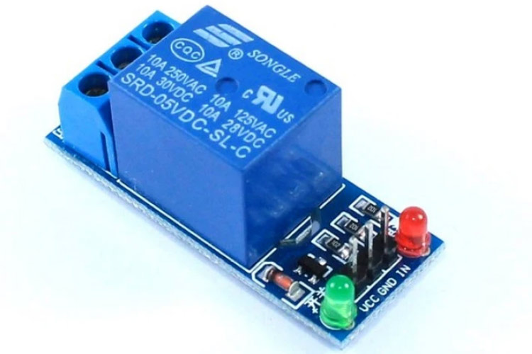

**Fig 5.1.3 Relay module**

A relay is an electrically activated switch. That works on the principle of an electromagnetic attraction. Relays are used where it is required to control a circuit by a free low-power signal, or where many circuits must be controlled by one signal. In current electric power systems, these functions are done by digital instruments.

# **5.1.4 WATER PUMP**

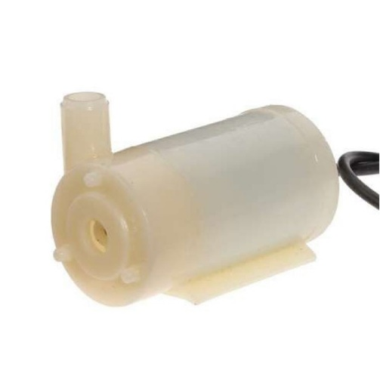

**Fig 5.1.4 Water pump**

The developed system consists of different IoT devices like a water pump. This information will be sent to the cloud and the user can analyse the amount of water. These sensor values are sending to the water pump via the relay to turn on/off the pump. If the values are less than the already set threshold values, then the motor stays in ON condition till the factor that is less than the threshold value reaches the threshold value. When the threshold value is reached, the relay automatically switches OFF the motor.

**CHAPTER VI**

**CONCLUSION AND FUTURE ENHANCEMENT**

**6.1 CONCLUSION**

The soil moisture detection system has been experimentally proven to work satisfactorily and we could successfully set the timer and managed to control the water pumping. Analysing the soil moisture, the system will automatically maintain water supply making it possible to maintain greenery without human intervention. If the moisture level goes to be below the desired and limited level, the moisture sensor sends the signal to the Arduino board which triggers the Water Pump to turn ON and supply the water to respective plant using the Rotating Platform/Sprinkler. When the desired moisture level is reached, the system halts on its own and the water Pump is turned OFF. Thus, the functionality of the entire system has been tested thoroughly and it is said to function successfully.

**6.2 FUTURE WORK**

The primary implementation for this project are for farmers and gardeners who do not have enough time to water their crops or plants. It also covers those farmers who are wasteful of water during irrigation. This principle can be extended to create fully automated gardens and farmlands. In agriculture lands with severe shortage of rainfall, this model can be successfully applied to achieve great results with most types of soil. This kind of mechanism may be used in all sorts of agriculture fields and mostly all kinds of plants. This method could also be used in homes to automatically water the plants when an individual is not at home. The data collected by this method could be used in data analysis to find out how fast moisture depletion takes place and which section requires more water. Therefore, the applications of the method are multiple.

**APPENDIX I**

**SAMPLE CODING**

int sensor_pin = A0;

int output_value ;

int pump = 8;

int threshold = 5;

void setup()

{

Serial.begin(9600);

pinMode(sensor_pin, INPUT);

pinMode(pump, OUTPUT);

Serial.println("Reading From the Sensor ...");

delay(1000);

}

void loop()

{

output_value = analogRead(sensor_pin);

output_value = map(output_value,550,0,0,100);

Serial.print("Moisture : ");

Serial.print(output_value);

Serial.println("%");

delay(1000);

if (output_value < threshold)

{

digitalWrite(pump, HIGH);

Serial.println("pump on for 1 second");

delay(1000);

digitalWrite(pump, LOW);

Serial.println("pump off");

delay(30000);

}

else

{

digitalWrite(pump, LOW);

Serial.println("do not turn on pump");

delay(30000);

}

}

**APPENDIX II**

**OUTPUT SCREENSHOTS:** 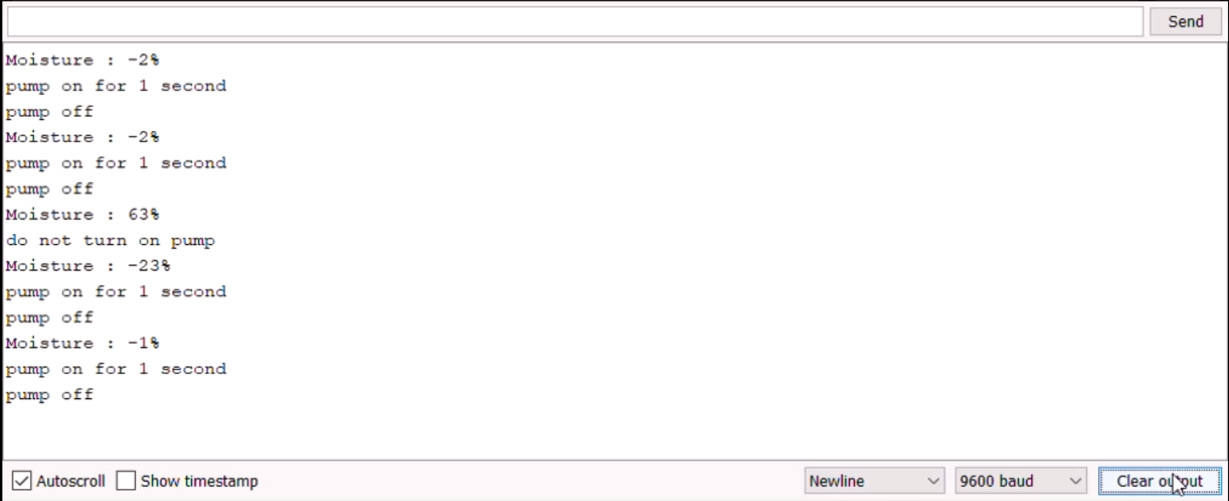

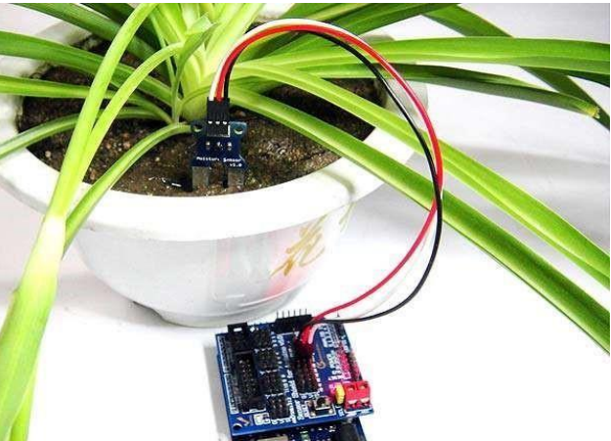

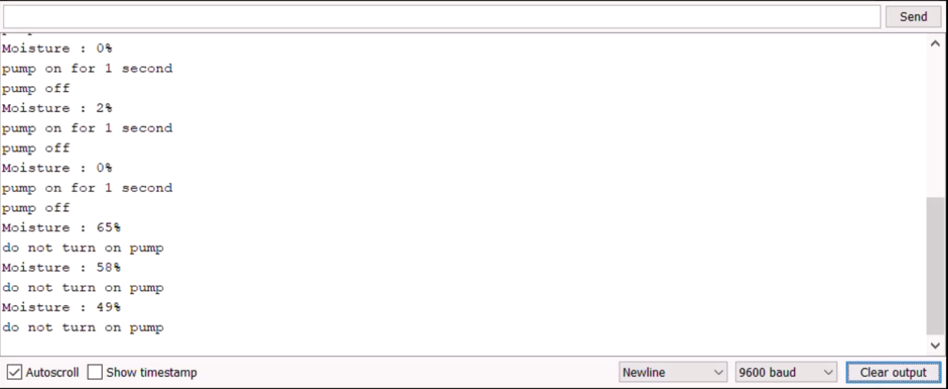

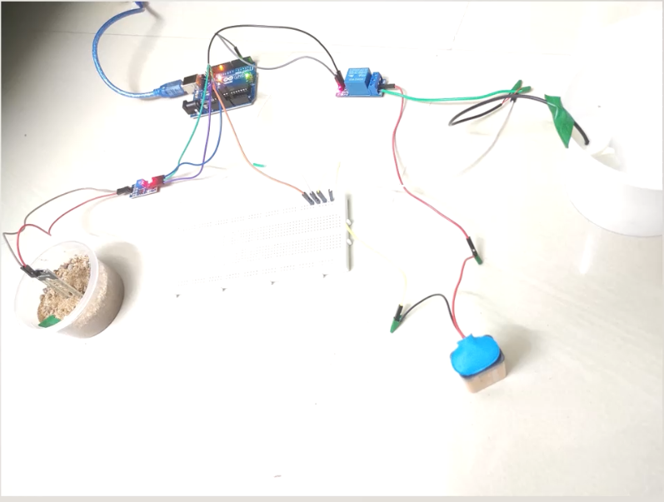

**REFERENCES**

[1] Indian Agriculture Industry. An Overview [Online]. Available from: <http://www.ibef.org/industry/agriculture-india.aspx>

[2] Decagon Devices: <https://www.metergroup.com/en/meter-environment/products/soil-moisture>

[3] Manual references:

<http://manuals.decagon.com/Bibliographies/soils.pdf>

[4] Linkedin references: <https://www.linkedin.com/pulse/paper-publication-iot-based-smart-agriculture-system-raghavendhar>

[5] Github reference: <https://github.com/Abhinish098/Soil-Moisture-Detection-System>